Question 4.1

This was a very Interesting project on a online e-commerce system.
The system covered everything about angular, the core and important concepts of the Framework.
Examples of Modules I used while building the app.

1)Router Module
this modules lets you create links and able to view different components on different URLs
I created 4 routes

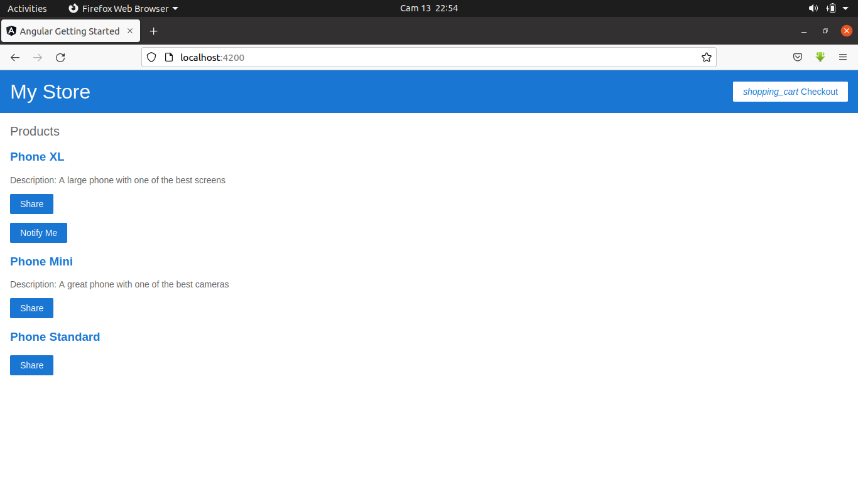
-The home to view home page as shown below

This lists the product lists.

-The Product component which displays a single Product which is passed as a parameter
this Route also helped to purchase the Product the single product.
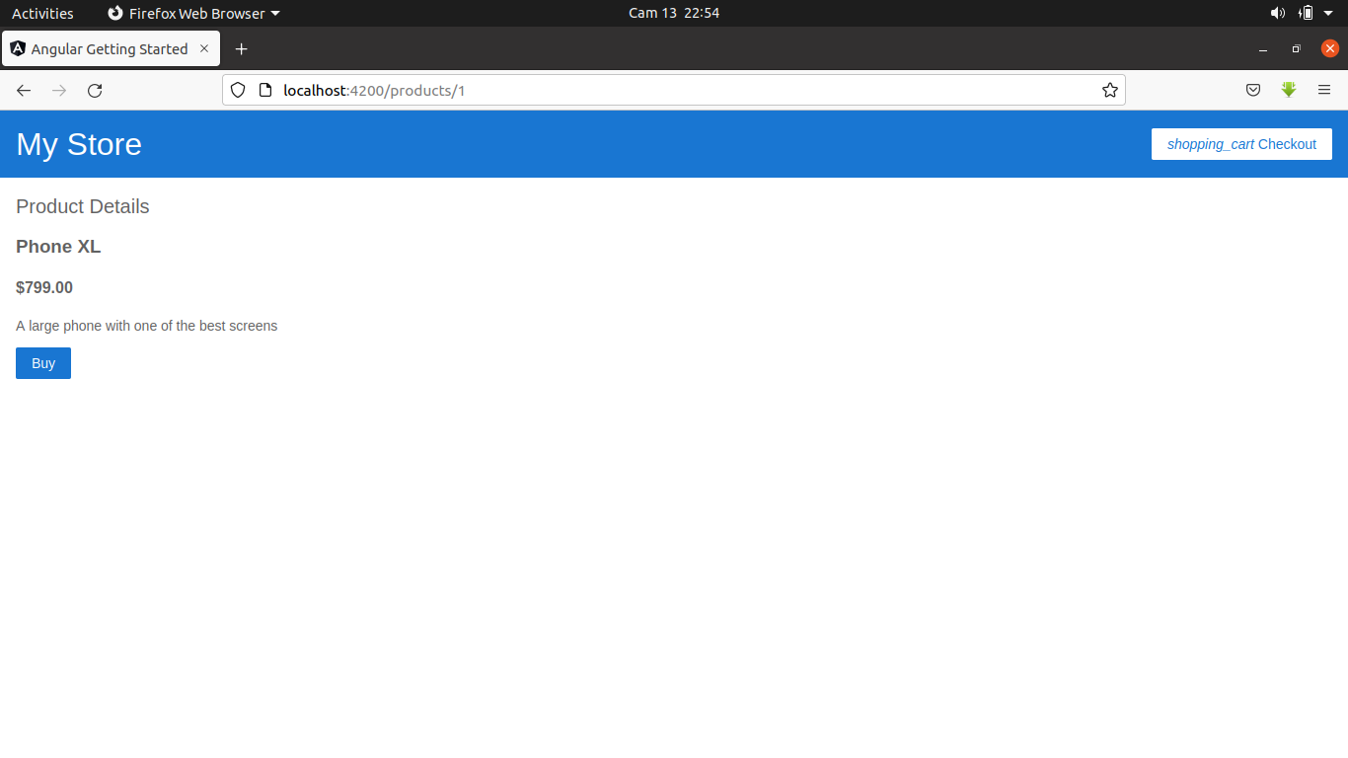
The following is a image of the Route

-The cart Route to store all the products which were ordered as shown I the figure below
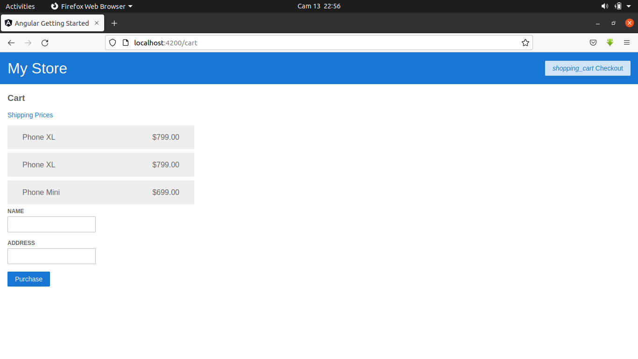

Once a single product is pressed the app gives a notification of order as shown bellow
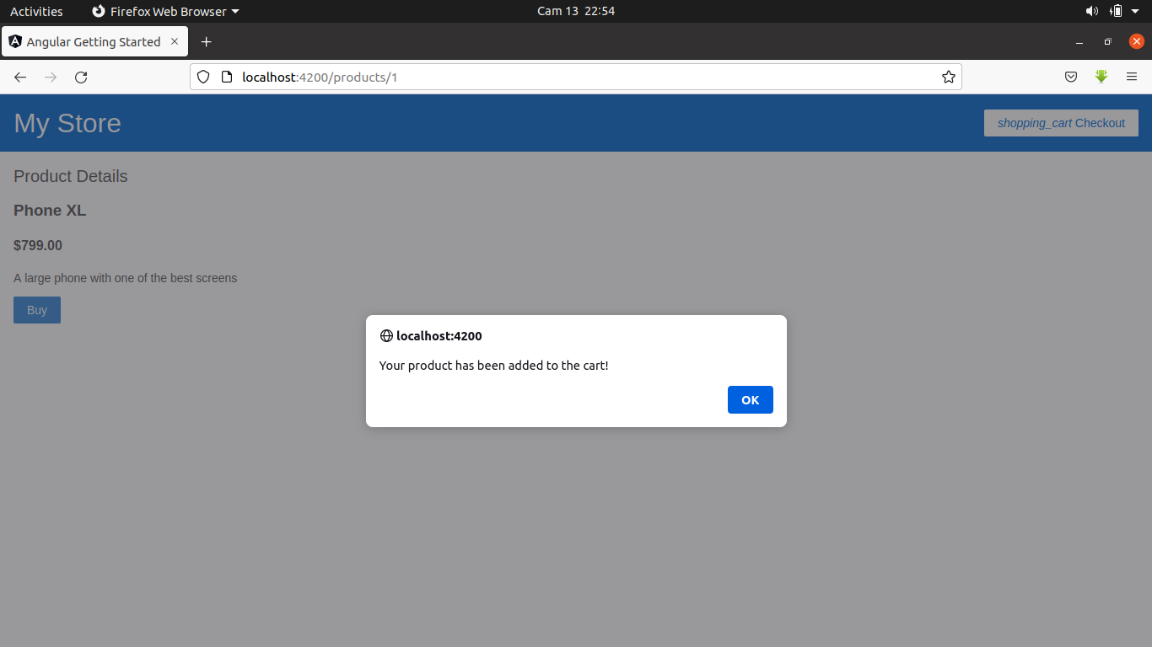

2)Form Module
This involved data binding.
For this I used two way data by using ngmodel to store and retrieve data from the form
when purchase button is clicked

3)HTTP Client Module

This involved sending and retrieving data from the endpoint using this module
This is a package that in other Frameworks download packages like axios to use for the endpoint
it support all the HTTP methods that is the GET,DELETE,POST,PUT ,PATCH and more

4.)Other Concepts

data injection
data binding and piping
state handling
Deployment to the cloud
Routing best practices
how to inject template as well as styles

